**Battle of Neighbourhoods**

**Business Problem:**

**Introduction**

This project will analyse neighbourhoods between Toronto- Canada and New York City- New York, USA. The borough Scarborough population is 6.32 lakhs, whereas Queens has population of 22.7 lakhs.

A Fortune 500 company plans to move its headquarters to a city that has good standard of living and quality of life. This project will work on the advantages and disadvantages between boroughs in two cities and determine which neighbourhood will be the best fit for the company's employees and headquarters.

**Objective**

Understand the similarities and differences of neighbourhoods between Scarborough in Toronto and Queens in New York city

To select the best neighbourhood for a Fortune 500 company to move its headquarters based on venues

**Questions that can be raised**

* Collect the neighbourhoods top venues
* Form neighbourhood based on venue categories using unsupervised k-means clustering algorithm
* Identify and understand the similarities and differences between the two borough neighbourhoods to obtain insights into the neighbourhoods
* Find where the population is dense and variety of venues

## Data Description:

The data used for this project will be acquired from the respective cities Wikipedia website pages. The datasets consists of the postal codes, neighbourhood names, latitude, and longitude information for each neighbourhood. Foursquare API search feature will be used to collect neighbourhood venue information. Details about local venues and locality will be provide insight into the qualities of a neighbourhood. In addition to Foursquare, various python packages will be used to create maps and machine learning models to further provide insights into our neighbourhood battle project.

#### For this project I've used the following data :

Toronto Neighbourhoods - <https://en.wikipedia.org/wiki/List_of_postal_codes_of_Canada:_M>.

Toronto Latitude and Longitude - <http://cocl.us/Geospatial_data>

New York City neighbourhoods- <https://geo.nyu.edu/catalog/nyu_2451_34572>

New York City Latitude and Longitude = Python Geolibrar

Description : This data set contains the required information. And we will use this data set to explore various venues in Scarborough -Toronto, Canada vs Queens- New York, USA.

Data source : Foursquare API : "<https://developer.foursquare.com/>"

Description : By using this API we will get all the venues in each neighbourhood.

**Map of Scarborough in Toronto**

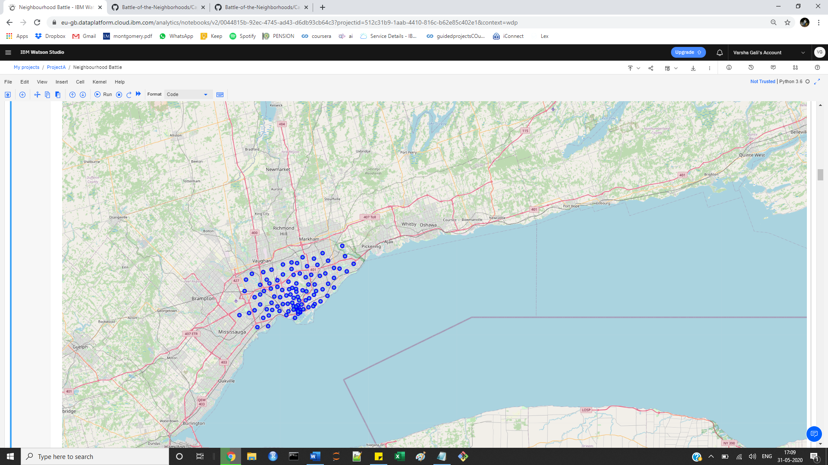

**Map of Queens in New York City**

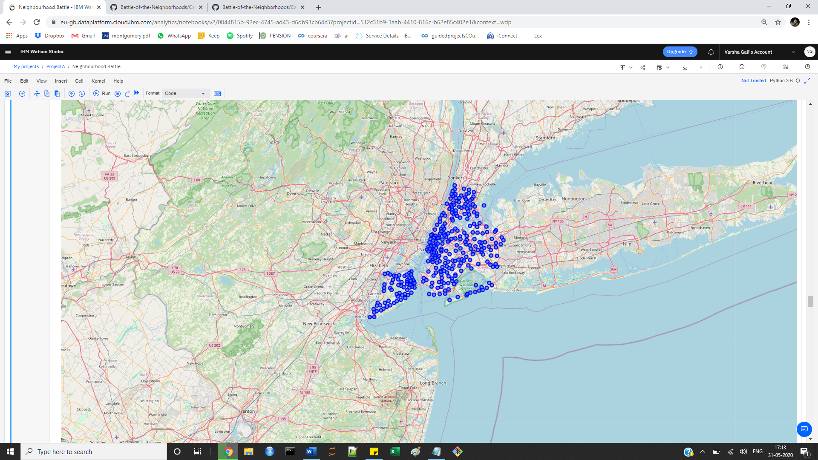

**Map of Scarborough in Toronto**

Different neighbourhood clusters

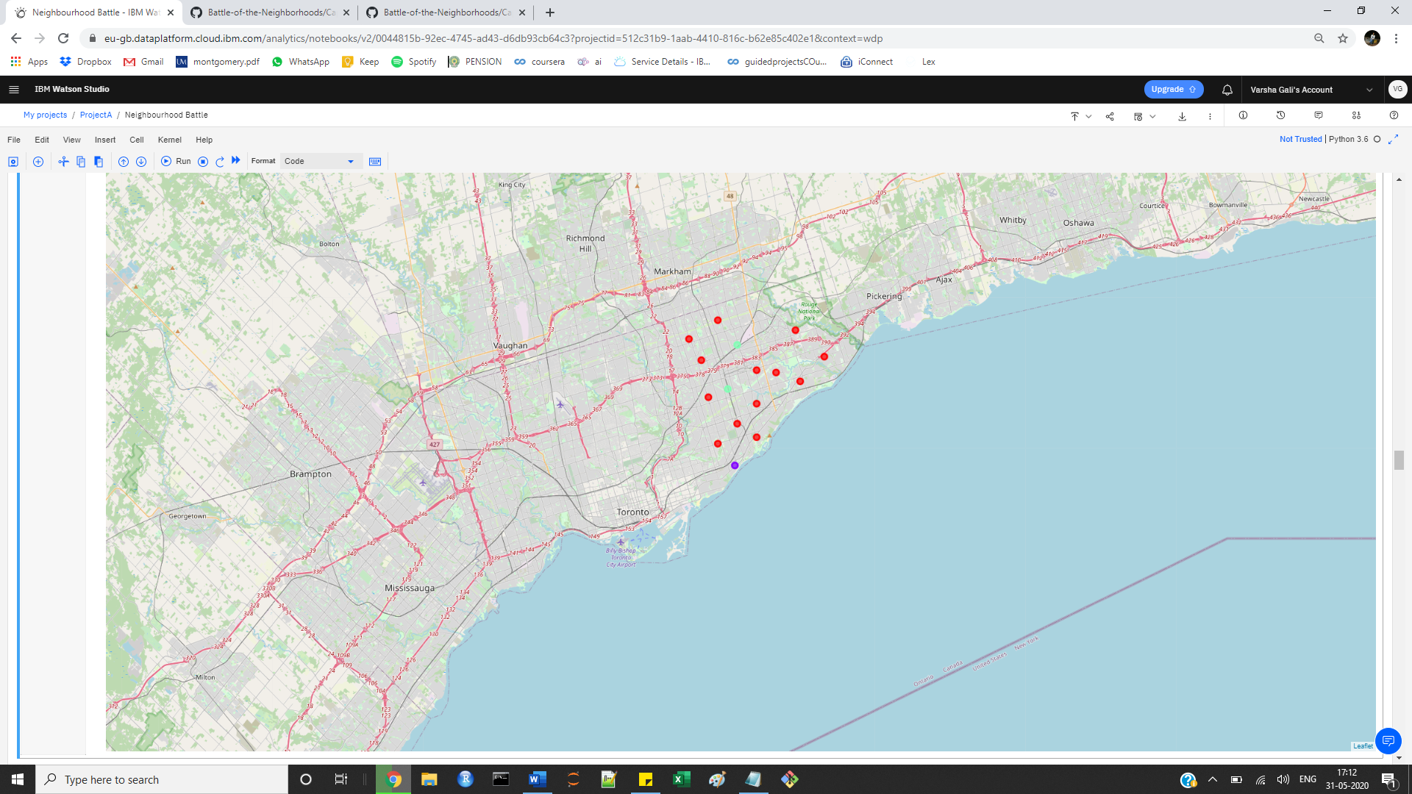

**Map of Queens in New York City**

Different neighbourhood clusters

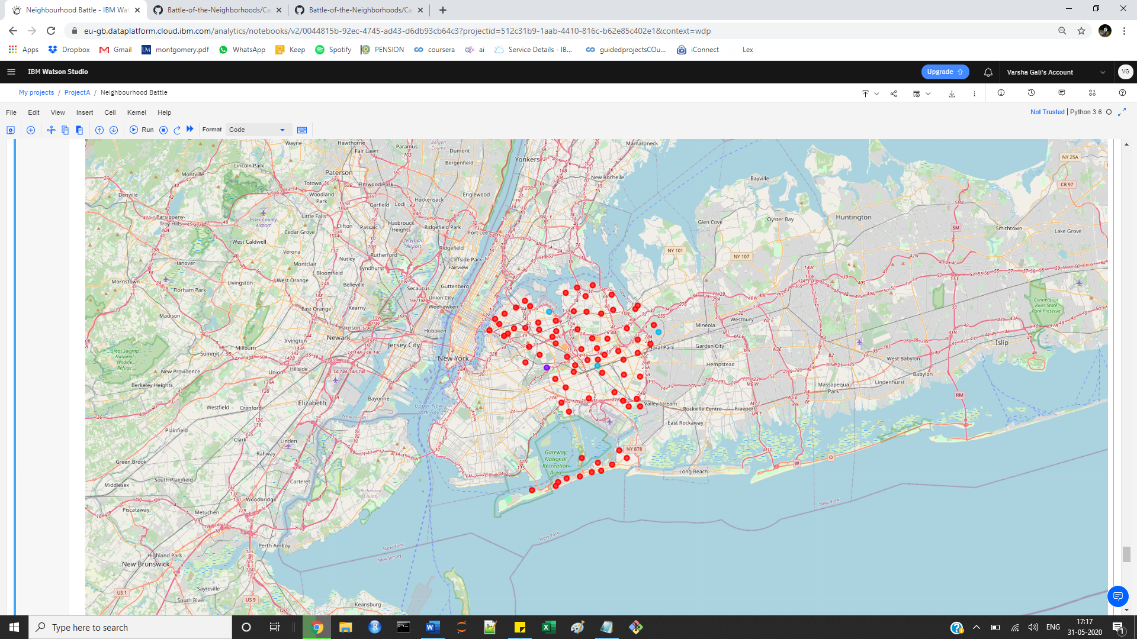

**Comparison between Neighbourhoods**

**Scarborough vs Queens**

Scarborough has 86 distinct venues in 57 categories

The most common venues in Scarborough are coffee

shops, international restaurants, and skating rinks

Queens has 1714 distinct venues in 273 categories

The most common venues in Queens are bodegas,

bakeries, coffee shops, and parks.

**Conclusion**

Based on the quantity of venues and variety of

venues, Queens is a better choice than

Scarborough to relocate the headquarters of the

Fortune 500 company. Queens offer a greater

amount of gyms, grocery stores, restaurants for

individual and families of the employees.